**III. BUILD AND EVOLVE AGILE TEAMS**

Introduction

Lesson Introduction

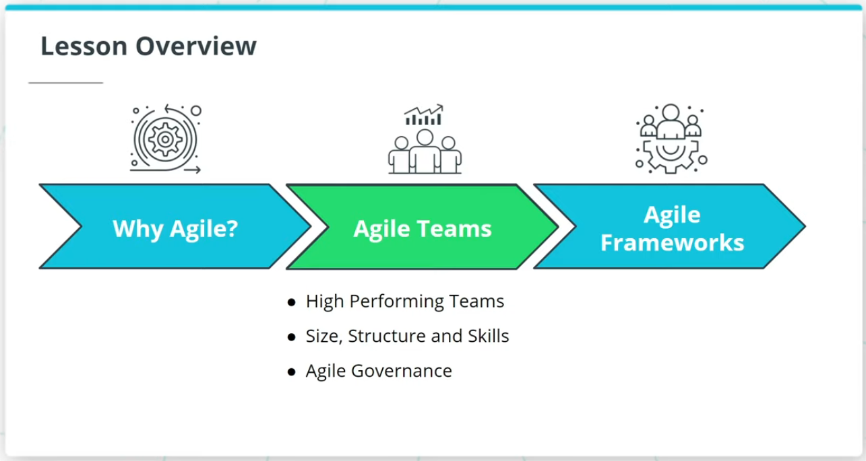

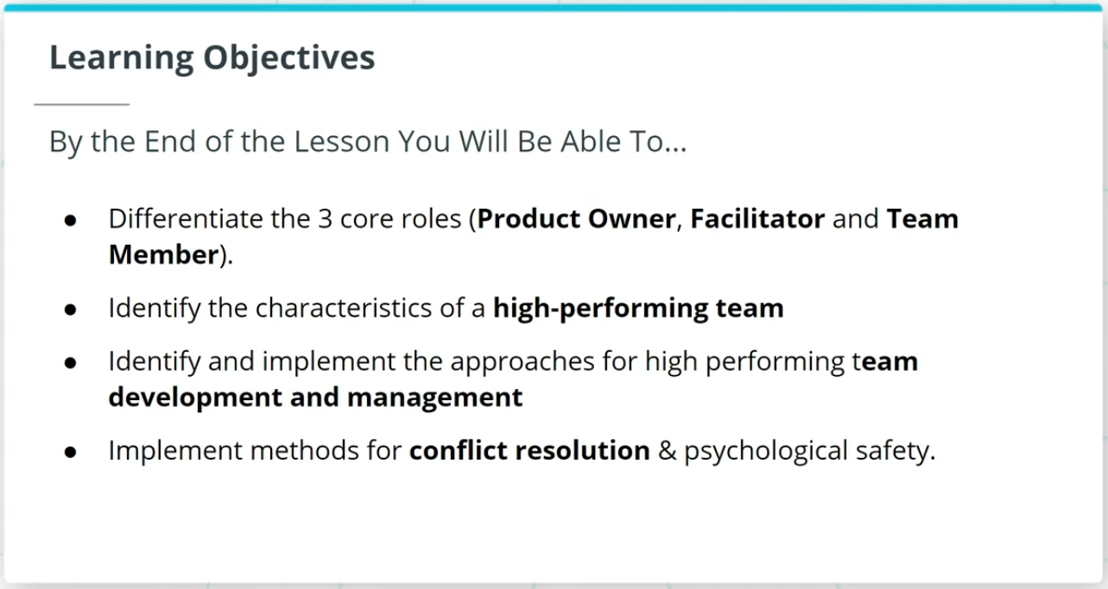

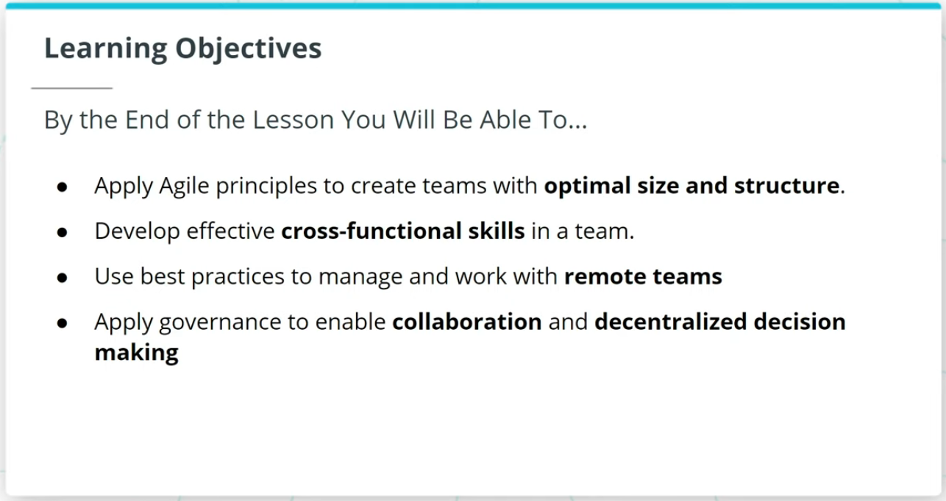

Welcome to a lesson on Agile Teams. In the last lesson, we talked about the importance of Agile.

This lesson will cover the following key topics:

### **High Performing Agile Teams**

* How Agile Teams are the vehicle that delivers valuable work tied to business-driven product features and functionality.
* Characteristics of a high-performing Agile Team.
* How to sustain High Performing Teams.

### **Size, Structure, and Skills of an Agile Team**

* The 3 core roles in Agile.
* An Agile Team’s optimal size, structure, and cross-functional skills.

### **Agile Governance**

* Agile Governance and how Agile governance leverages The Agile Manifesto’s guidelines to balance assurance with adaptability.

### **By the End of the Lesson, You Will Be Able To...**

* Differentiate the 3 core roles (Product Owner, Facilitator, and Team Member)
* Identify the characteristics of a high-performing team
* Identify and implement the approaches for high performing team development and management
* Implement methods for conflict resolution & psychological safety
* Apply Agile principles to create teams with optimal size and structure
* Develop effective cross-functional skills in a team
* Use best practices to manage and work with remote teams
* Apply governance to enable collaboration and decentralized decision making

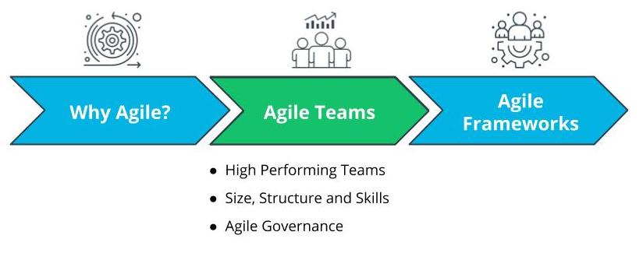

Lesson Overview - Agile Teams